Monday
Read the story first. Then, cut up the story into individual rectangles. Mix them up and then try to stick them back into the correct order. After doing this, think about what other Fairy Tales/Traditional Tales you know. How are they similar? How are they different? Why not read one of your favourites to someone else?
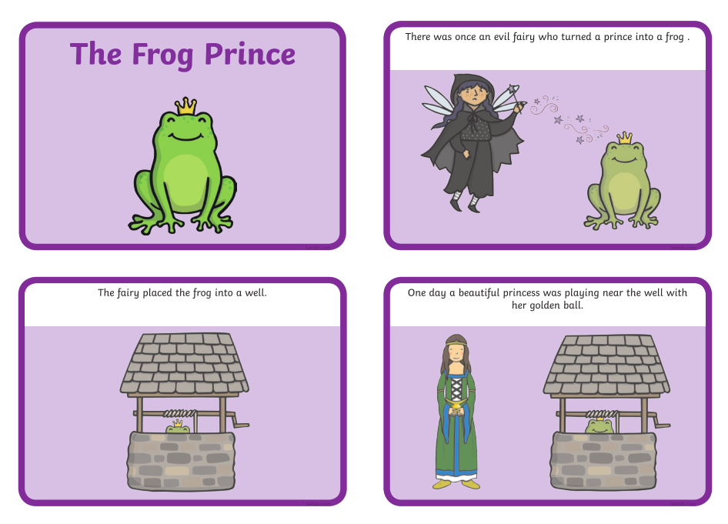
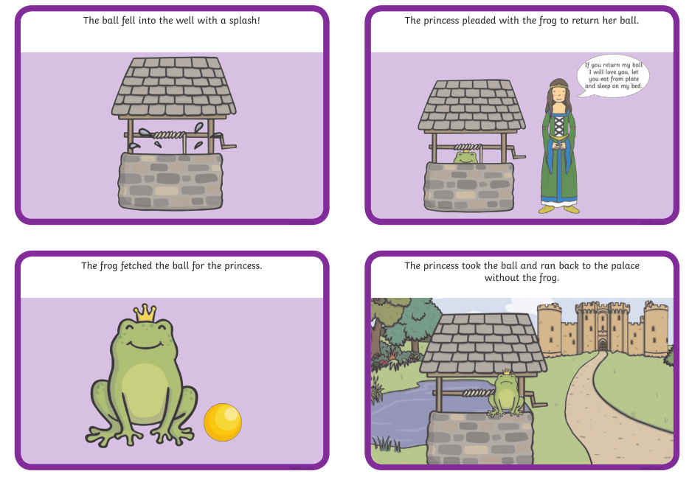
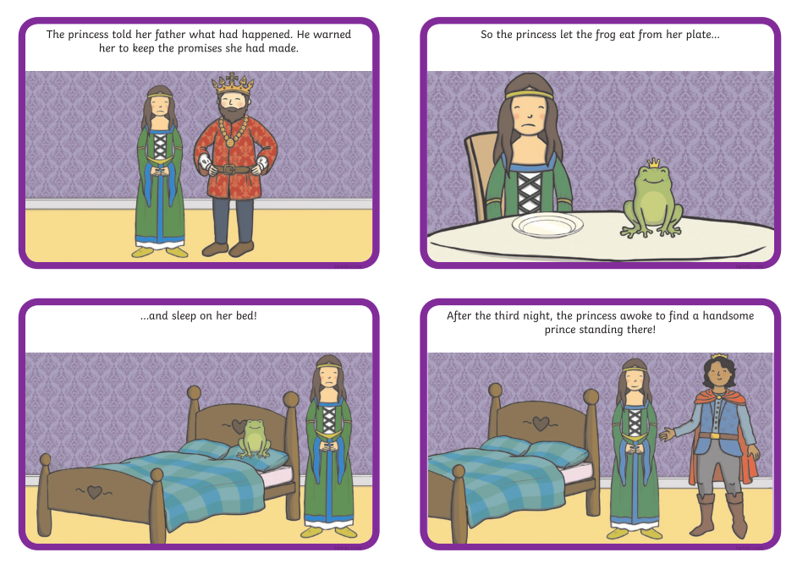

Tuesday
Look again at the story of the Frog Prince. Write a newspaper article about this amazing story of the Prince turning in to a frog! Use the word mat to help you with some of the trickier words. You may like to have a look at a child’s newspaper (like The Week Junior or First News) or magazine to see the style of how articles are written before you start. If you don’t have access online, or otherwise, to children’s newspapers or magazines, maybe a grown up could read you a suitable article from an adult newspaper so that you can copy the style. Factual writing is different to story telling.
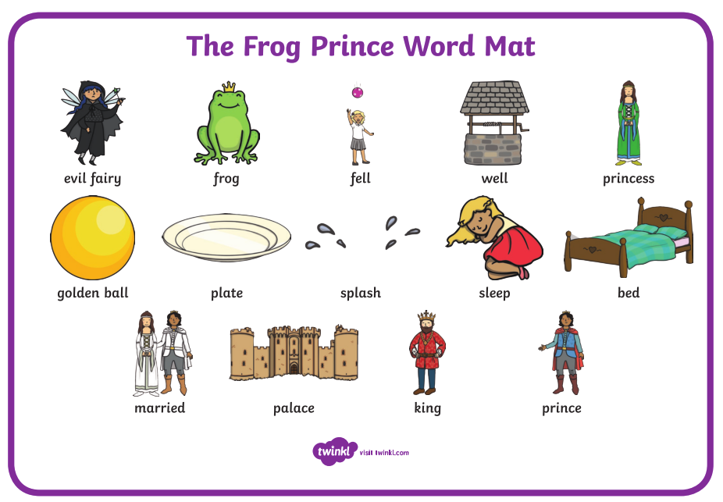

Wednesday
Imagine that you are the princess in the story. Write about the story from her point of view. You could act it out first if you like to help you. You could call it ‘The day that I found a frog down a well’ or ‘How I found my prince’.

Thursday
Pretend that you are the frog and write a diary entry as a day in the life of a frog. Think about what a ‘normal’ diary entry might look like, before you think about writing one as a frog!

Friday
Make up a story about a different animal prince, like ‘The Snail Prince’ or ‘The Dog Prince’. You can choose any animal you like. Your story must NOT contain a frog, a ball, or a well. Have fun!

