Tuesday 19th May – Maths
Today we are going to have a look at formal methods using addition.
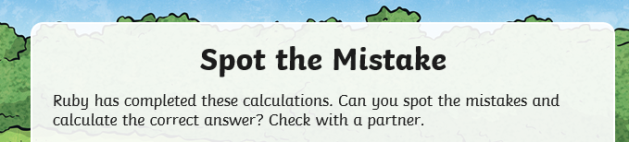

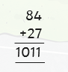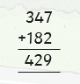

Have you spotted the mistakes? Here is the answer to check:
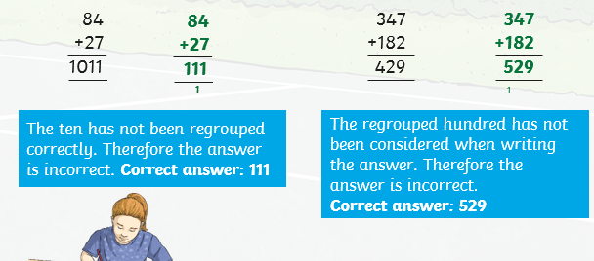

Task
