Wednesday Afternoon – D & T
Look at these war posters.
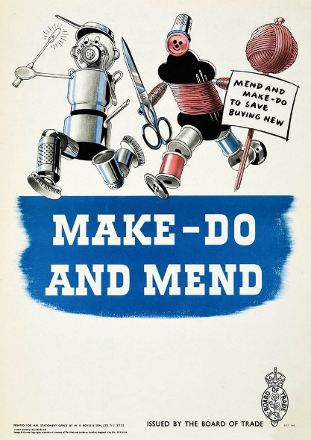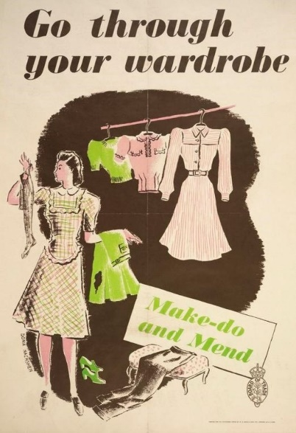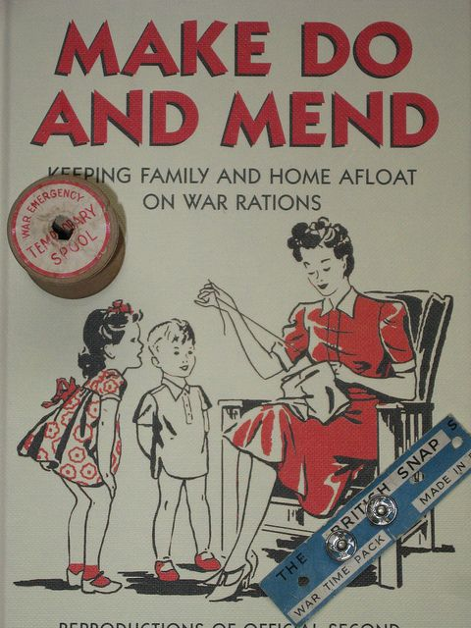
Either design your own make do and mend poster that would show the importance of reusing and recycling during the war or take an item of clothing and turn into another usable item – we’d love to
see pictures of your designs and outfits.

