Literacy Resource Pack – Week Beginning 18th May 2020

- Literacy Task 1 Answer the reading comprehension questions for the chapter.
- Literacy task 2 Based on your knowledge of the first 3 chapters which you have now read, complete the sheet describing the appearance and behaviour of Willie and Mister Tom.
- Literacy task 3 Read each extract from chapters 1,2 and 3 and explain the thoughts and feelings of the character.
- Literacy task 4 Design a character profile for Willie Beech. Use your new understanding of the character to make this detailed with descriptions with his physical features. Can you challenge yourself by using quotes from the text to annotate the sketch?
- Literacy task 5 Look at the questions to be asked to Willie. Choose 3 and answer them in character. Write in full sentences and using the top tips.
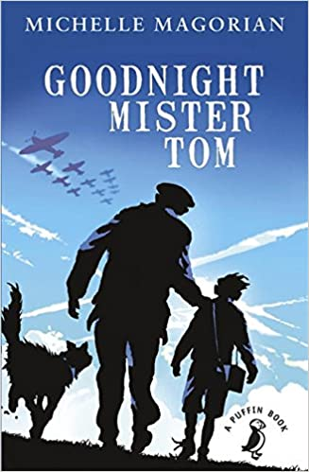
Literacy Task 1 Answer the reading comprehension questions for the chapter.
Reading Comprehension Questions – Chapter 3 Goodnight Mister Tom
Top Tip: use EVIDENCE from the text to back up each answer you give

(VOCABULARY) Which words show us how Willie was treated in London?
(INFERENCE) Why does Willie want to keep his socks on?
(PREDICT) How do you think Tom would interact with Willie’s mother if they met?
(EXPLAIN) Explain why Willie is so surprised that Tom is giving him praise.
(RETRIEVE) Why was the gate so difficult to open?
(SUMMARISE) How could you summarise the third chapter in a sentence? In a phrase? In a word (concept)?

Literacy task 2 Based on your knowledge of the first 3 chapters which you have now read, complete the sheet describing the appearance and behaviour of Willie and Mister Tom.
.
Literacy task 3 Read each extract from chapters 1,2 and 3 and explain the thoughts and feelings of the character
Literacy task 4 Design a character profile for Willie Beech. Use your new understanding of the character to make this detailed with descriptions with his physical features. Can you challenge yourself by using quotes from the text to annotate the sketch?

Literacy Task 5- Here are some questions which Matthew W would ask Willie Beech. Choose 3 and answer in character. Write in full sentences and use emotive language from the text.
Top Tips
- Emotive language
- First person
- Fronted adverbial
- Co-ordinating conjunction
- Parenthesis (brackes, commas, dashes)

