Y3 Newsletter
Week Beginning 18th May 2020 – Growth Mindset Theme – Find lessons and inspiration in the success of others.

Dear parents and carers,
We hope that you're still all keeping safe and well.
This will be our last newsletter for this half term. We would just like to take this opportunity to say a big thank you to you, for continuing to be such resilient and hardworking Highweek Learners. Stay safe and keep in touch. Happy half term!
Challenges we have faced this week -
Miss Sanchez – I had a go this week at challenging Miss Romain to go for a run. Since the lockdown started, Archie and I have put a lot of effort in, running every morning. It was a challenge at the beginning however, it has become easier. Archie has become a good runner, often he is off the lead enjoying all the smelly things he can find.

Miss Romain – Well children I did it! Just like making the Spanish Dish last week. However, it has taken a lot of effort to get out jogging, and is certainly not every day like Miss Sanchez. Perhaps taking a dog might help? I feel so great after it and love finding new local routes to run. This is me in the back lanes near my house. I ran for 30 minutes, which felt amazing. I hope we are inspiring you all with your challenges too
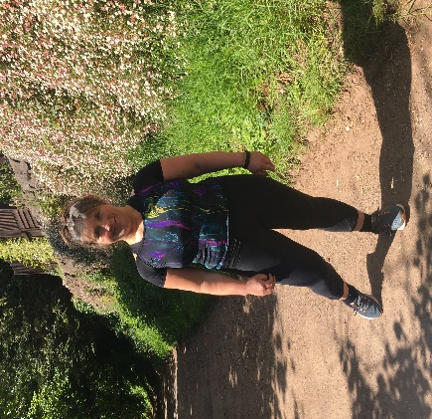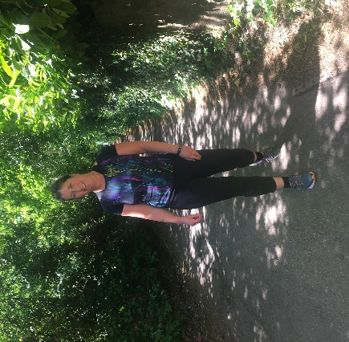
A big ‘Shout Out’ to Herbie Powesland from Plym class who took on the Youth Sport Challenge of Tuck In and Out in 60 seconds. He managed to achieve an incredible 34 tucks. Well done Herbie. If anyone else has had a go at one of these challenges or anything else you would like to share with us we would love to know.
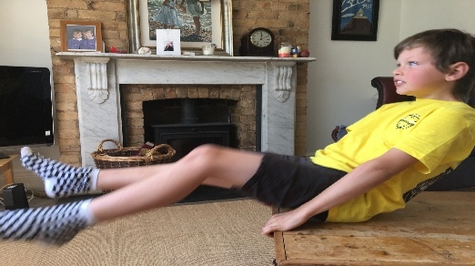
We now have access to a new online SPAG test that you can have a go at. We have set the first test for all of you in Year 3. If you would like to have a go, please email us and we can provide you with your login details. It is fun and helps us understand the areas you need more support with.

Our emails are provided below
Miss Romain vromain@highweekprimary.co.uk
Miss Sanchez CFSanchez@highweekprimary.co.uk
Take care and be kind to each other.
Kind Regards
Weekly links should you wish to access these are below
Maths
- Play on Hit the Button on Topmarks – times tables, doubles, halves.https://www.topmarks.co.uk/maths-games/hit-the-button
- Complete a set of Daily 10s on Topmarks. Choose a set of questions from level 1,2 or 3 and work on gradually decreasing your time. https://www.topmarks.co.uk/maths-games/daily10
- Practise times tables including 3x, x6, 4x and 8x table
- Practise telling the time. Read analogue and digital clocks.
- Practise multiplying and dividing numbers by 10.
- Choose an activity or game to do from the Nrich website. https://nrich.maths.org/9084
- Use Maths with Carol Worderman. https://www.themathsfactor.com/
Spelling, Punctuation and Grammar
- Practise spellings from the Year 3/4 statutory word list available online and sent out in your pack last week. You can make a pyramid, bubble writing, a bee, a sun and also some sentences with them.
- Spell the days of the week/months of the year in a diary.
- Learn these 4 words (occasionally, often, opposite, ordinary) from the statutory word list to learn for the week and hold a spelling test at the end of the week with someone in your family or simply test yourself if you prefer.

Reading Tasks
- Continue to read a variety of books at home. Your child could share part of a book with you each day. Encourage them to discuss what they have read and look out for any interesting vocabulary. Remember you can still quiz at home! Well done to all of you who has quizzed last week. Your count is going up, so keep reading. Alternatively you can listen to some David Walliams https://www.worldofdavidwalliams.com/elevenses/
- Watch BBC Newsround and find out what is happening around the world.
- Don’t forget the First News Comprehension sheets too

PE
With our ongoing work and partnership with South Dartmoor College we are linking our PE challenges with the Youth Sport Trust 60 Second Challenges. Please see the link below for
https://www.youtube.com/watch?v=2bae-Gm3mG0 Bean Bag Throw Challenge
(hard copy available in School Pack)
We know that after half term the School Games Organisers are putting together a Virtual Summer Games for all to take part in and thought this first activity 'Bunny Jumps' would serve as a good warm up for the week ahead. There will be other challenges provided in the weeks to come.
Sustrans – Journey to School, Keeping Active (hard copies in your pack)
Don’t also forget to take part in Joe Wicks’ “The Body Coach” daily sessions live on YouTube each weekday morning at 9am.

Wellbeing
Mindup – keep having regular brain breaks using the Core Practice. This week see your afternoon activity for this too. You can access the Mindup website for more ideas here: https://mindup.org.uk/mindup-activities/
- Try out some yoga. Yoga with Adriene is really calming No mat is required but you may want to use a towel and cushion https://www.youtube.com/watch?v=vMMRb10LtGM

Other ideas
Love animals? Check out the webcams at Edinburgh Zoo. The penguins are particularly entertaining! https://www.edinburghzoo.org.uk/webcams/

